**Exercise 13: Parameters, Unpacking, Variables**

1. Try giving fewer than three arguments to your script.

**first, second, third = ARGV**

**puts "First variable is: #{first}"**

**puts "Second variable is: #{second}"**

**puts "Third variable is: #{third}"**

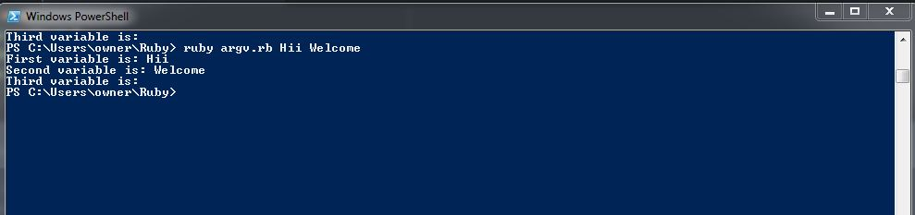

1. Write a script that has fewer arguments and one that has more. Make sure you give the unpacked variables good names.

**s, s1 = ARGV**

**puts "First String: #{s}."**

**puts "Second String: #{s1}."**

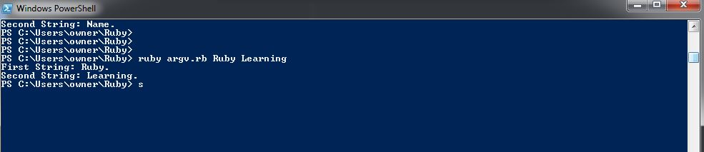

1. Change your script to use $stdin.gets.chomp everywhere that you have gets.chomp. You should use $stdin.gets.chomp from now on since the action gets.chomp has problems with ARGV.

**puts "Enter some Money"**

**n = $stdin.gets.chomp.to_f**

**m = n*0.10**

**puts "Your change is #{m.round(2)}"**

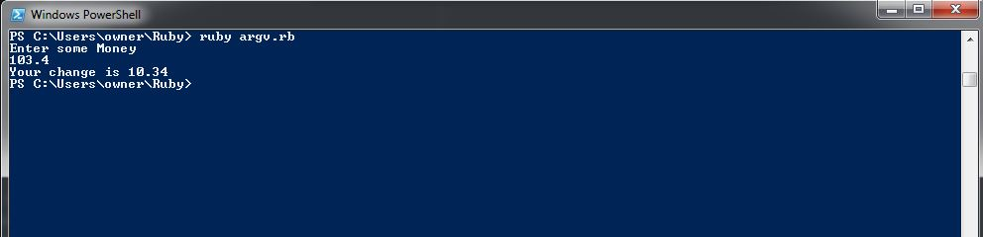

1. Now that you are using $stdin.gets.chomp (see #3) you can add ARGV to your script to get something from the user. Don't over think this. Just use ARGV to get one thing, then $stdin.gets.chomp to get something else.

**f = ARGV**

**puts "Your favorite #{f}: "**

**favorite = $stdin.gets.chomp**

**puts "Your Favorite #{f} is #{favorite}...."**

